

**BTEP**

Mid Term Project Report

**Topic: Enhancing Agricultural Spatial Data Infrastructure for Indian Farmers**

Submitted by: Vatsal Patel AU2040043

Submitted to: Prof. Sanjay Chaudhary

**Abstract**

India's agriculture sector is the backbone of its economy, employing a significant portion of the population and contributing significantly to GDP. However, the sector faces numerous challenges, including unpredictable weather patterns, inadequate infrastructure, and limited access to modern technologies. Spatial data technologies offer a promising solution to these challenges by providing farmers with timely and accurate information about their environment and agricultural resources. Indian agriculture is highly dependent on factors such as weather patterns, soil conditions, and access to resources like cold storage facilities. However, farmers often lack access to reliable spatial data that can help them make informed decisions about crop management, resource allocation, and risk mitigation. By developing a spatial data infrastructure specifically designed for Indian farmers, aim is to empower them with the information they need to improve productivity, enhance resilience, and sustainably manage their agricultural operations.

**Problem Statement**

This project aims to develop a comprehensive spatial data infrastructure tailored to the needs of farmers in India. The aim is to provide farmers with valuable insights into various aspects of agriculture, including crop growth history, soil types, average atmospheric conditions, availability of cold storage facilities, etc.

**Literature Survey and Market Analysis**

Previous studies have demonstrated the potential of spatial data technologies to improve agricultural decision-making and enhance productivity. Research has shown that access to spatial data on factors such as soil types, weather patterns, and market prices can help farmers optimize resource allocation, minimize risks, and increase yields. However, existing spatial data infrastructures often lack the granularity and accessibility needed to address the specific needs of Indian farmers. Any available facility is also not easy to use. The agricultural sector in India represents a vast market opportunity for spatial data technologies. With over 50% of the population engaged in agriculture and increasing adoption of digital technologies across rural areas, there is a growing demand for tools and platforms that can provide farmers with actionable insights and support. By catering to this market demand, this spatial data infrastructure has the potential to make a significant impact on agricultural productivity and livelihoods.

**Technology**

The key technologies employed in our project include:

**Apache Tomcat**: We have leveraged Apache Tomcat as the web server and servlet container to host our web application. Apache Tomcat provides a robust and scalable environment for serving dynamic web content and handling HTTP requests from users' web browsers.

**GeoServer**: GeoServer serves as the backbone of our spatial data infrastructure, allowing us to publish, serve, and visualize geospatial data layers over the web. It supports standard protocols such as WMS, WFS, and WCS, enabling seamless integration with our web application and facilitating the retrieval and rendering of spatial data.

**PostgreSQL** with **PostGIS**: PostgreSQL is employed as the relational database management system, augmented with the PostGIS extension for spatial data handling. This combination allows us to store and manage various types of agricultural spatial data efficiently, while also providing powerful spatial indexing and querying capabilities.

**OpenLayers**: OpenLayers is utilized on the front-end to create interactive maps within users' web browsers. It communicates with GeoServer to fetch spatial data layers and renders them dynamically on the map interface, enabling users to explore and interact with agricultural data visually.

**Architecture**

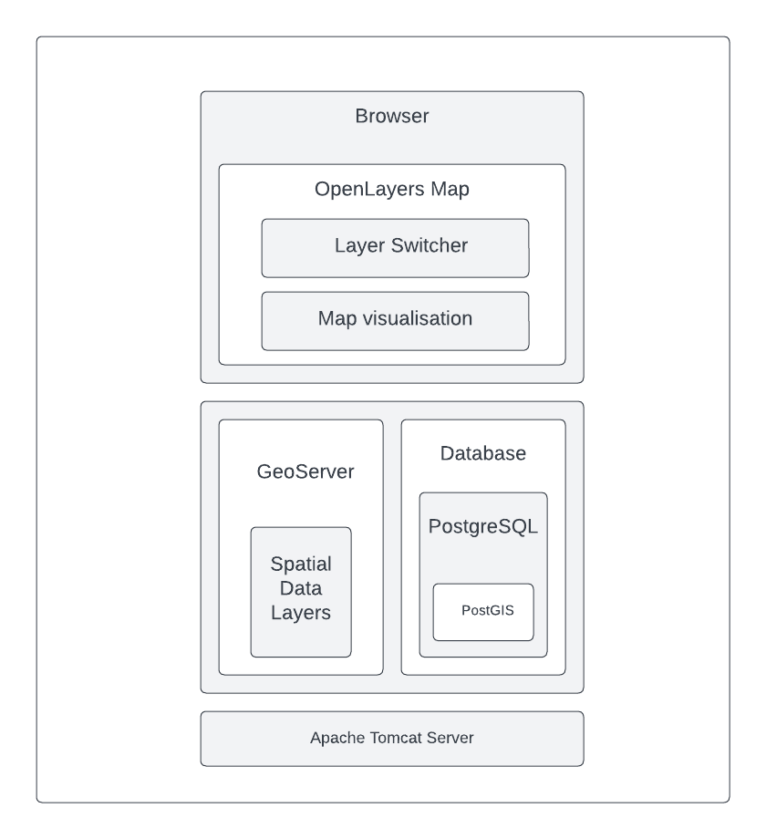

**Explanation**

**User Interface** (Web Browser): This is the front-end interface accessible to users via a web browser. It displays the map visualization created using OpenLayers and allows users to interact with spatial data layers.

**OpenLayers Map**: OpenLayers is used to create the interactive map interface within the web browser. It fetches spatial data layers from GeoServer and renders them on the map for visualization.

**Layer Switcher**: The layer switcher component allows users to manage the visibility of different spatial data layers on the map. Users can select which layers they want to display or hide, providing flexibility in data exploration.

**Map Visualization**: This component visualizes spatial data layers retrieved from GeoServer on the map interface. Users can interact with the map, such as zooming in/out, panning, and clicking on features for additional information.

**GeoServer**: GeoServer serves as the back-end server responsible for serving spatial data layers to the web interface. It retrieves spatial data from the PostgreSQL database, processes requests from the web interface, and generates map images for visualization.

**Database** (PostgreSQL with PostGIS): PostgreSQL is used as the relational database management system, with PostGIS extension for spatial data handling. It stores various types of agricultural data, including crop growth history, soil types, and district boundaries, in a structured manner for efficient retrieval and processing by GeoServer.

**Apache Tomcat Server**: Positioned alongside the GeoServer and the database, Apache Tomcat serves as the hosting environment for the web application. It runs the server-side components of your application, handling HTTP requests from users' web browsers, executing server-side scripts, and communicating with GeoServer and the database to retrieve and manipulate spatial data as necessary.

**Results**

Apache Tomcat Server

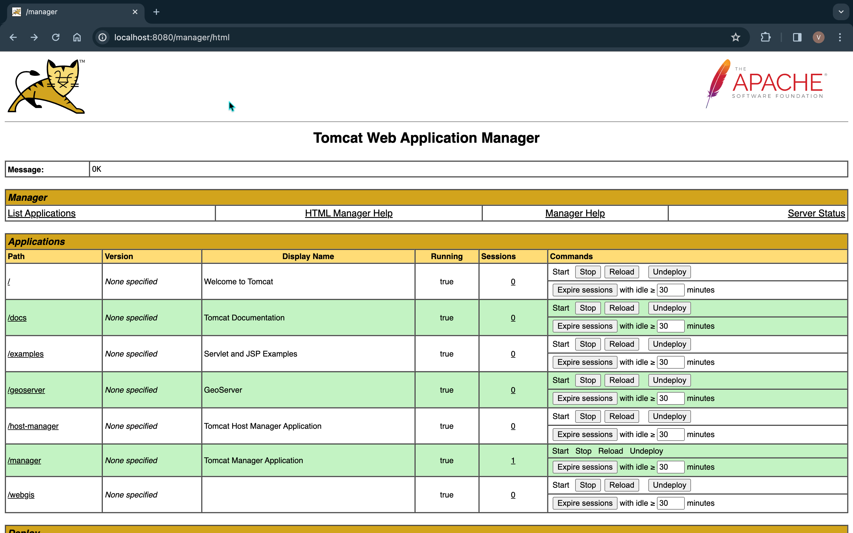Geoserver layers

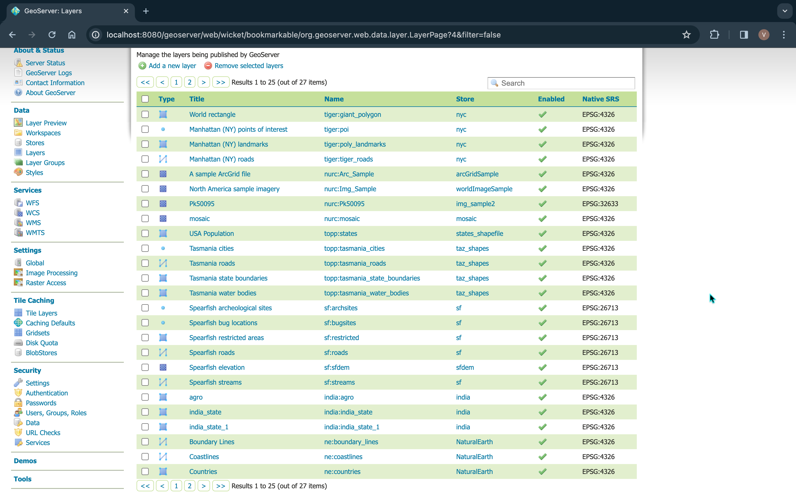

Frontend (in progress)

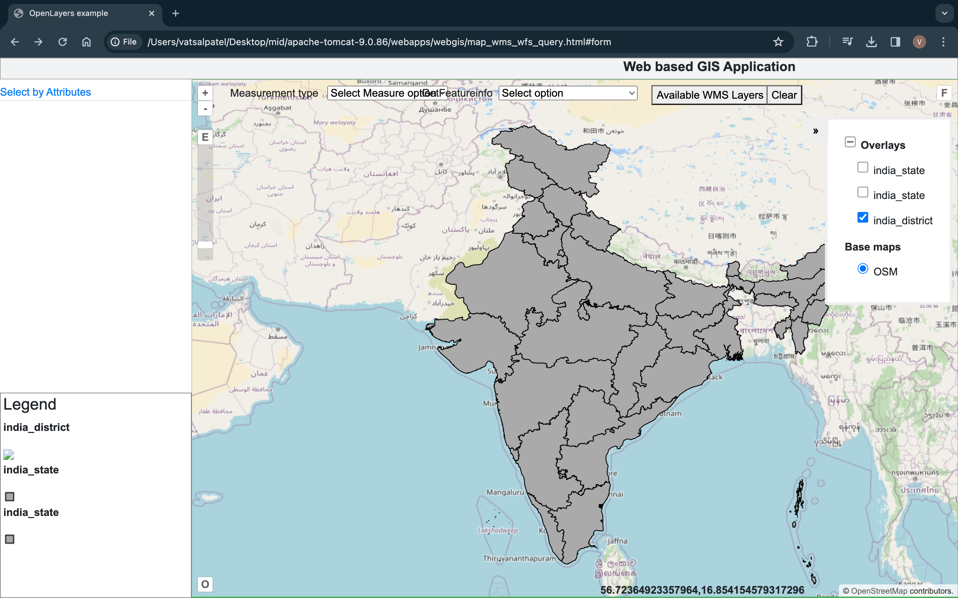

**Next Steps**

Several key tasks have been identified for the upcoming phases. These tasks are critical for enhancing the functionality, usability, and availability of spatial data for farmers in India. The next steps of the project include:

**Finding Data for Features to be Made Available**:

In order to enrich the spatial data repository, plan is to find appropriate data sources to augment the features to me made available on the website.

Extraction of relevant data from various sources, including government websites, agricultural databases, etc. This data will provide valuable insights to farmers and enhance the scope of information available through our platform.

**Converting the Data into Geospatial Format**:

Once the data has been collected and curated, the next step involves converting it into geospatial format for integration into the spatial database. This may involve georeferencing data points, digitizing spatial features, and organizing attribute data.

We will leverage tools and techniques for data transformation and geospatial processing to ensure that the scraped data is compatible with our existing spatial data infrastructure. This will involve converting data into standard formats such as shapefiles, GeoJSON, or CSV with spatial coordinates.

**Rendering the data on frontend:**

This data needs to be rendered on the webapp. Each type of geospatial data requires its own specification on the geoserver to render it properly. For the website to be easily usable for the farmer, different types of data such as polygons, points, etc need to be displayed appropriately. That needs to be configured

**Fixing the Frontend of the Web Application**

One of the key enhancements planned for the frontend of our web application is the implementation of a layer switcher component. This will provide users with greater control over the visualization of spatial data layers and enhance the overall usability of the platform. Prioritize the development and integration of the layer switcher functionality into the user interface, allowing users to toggle the visibility of different layers, customize map views, and explore spatial data more effectively.

Additionally, addressing any existing issues or improvements identified during user testing and feedback sessions to ensure a seamless and intuitive user experience. These next steps represent crucial milestones in the evolution of our agricultural spatial data infrastructure project.

**Deployment on AWS**

As a final step, the project will be deployed on Amazon Web Services (AWS) to ensure scalability, reliability, and accessibility of the spatial data infrastructure.